15th October 2018

I started today by drawing the volume meter for the GUI, that all seems to be fine.
Now I am going to make the little music player, first I just need to find out how to make scrolling text.

Actually I might first look at finishing the two main bars, as that is the bulk of what I want there.

As of 12pm I have this:
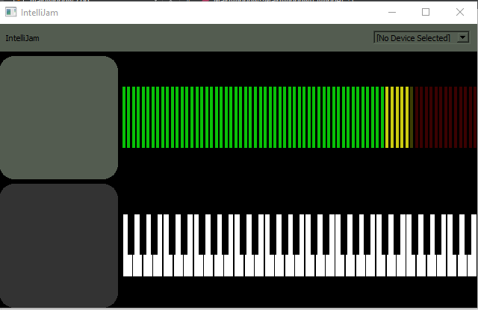

This is pretty good going so far, I think. I just need to sort out some of the text etc.

For now (1pm), I’m gonna work on getting the control bar in, cos I think that would be useful.

Things that need to be looked at:
Dynamically sizing the buttons on the bottom bar
Dynamically sizing the text on the name tiles?
Sorting out the bottom play widget
Sorting out the top bar/logo as well.

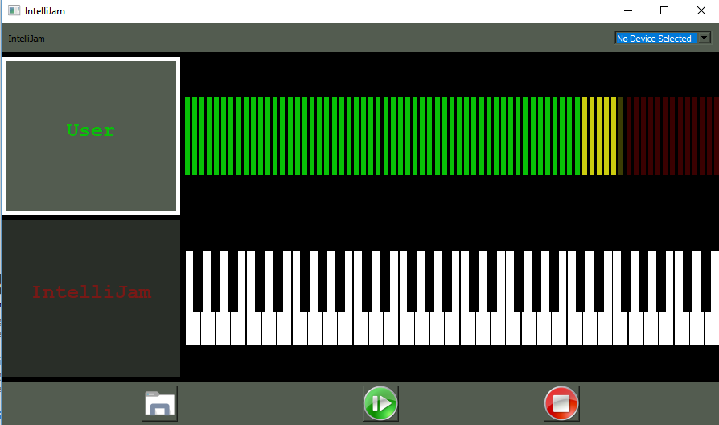

That’s what I’ve got as of 4pm. The rest I can do tomorrow.

